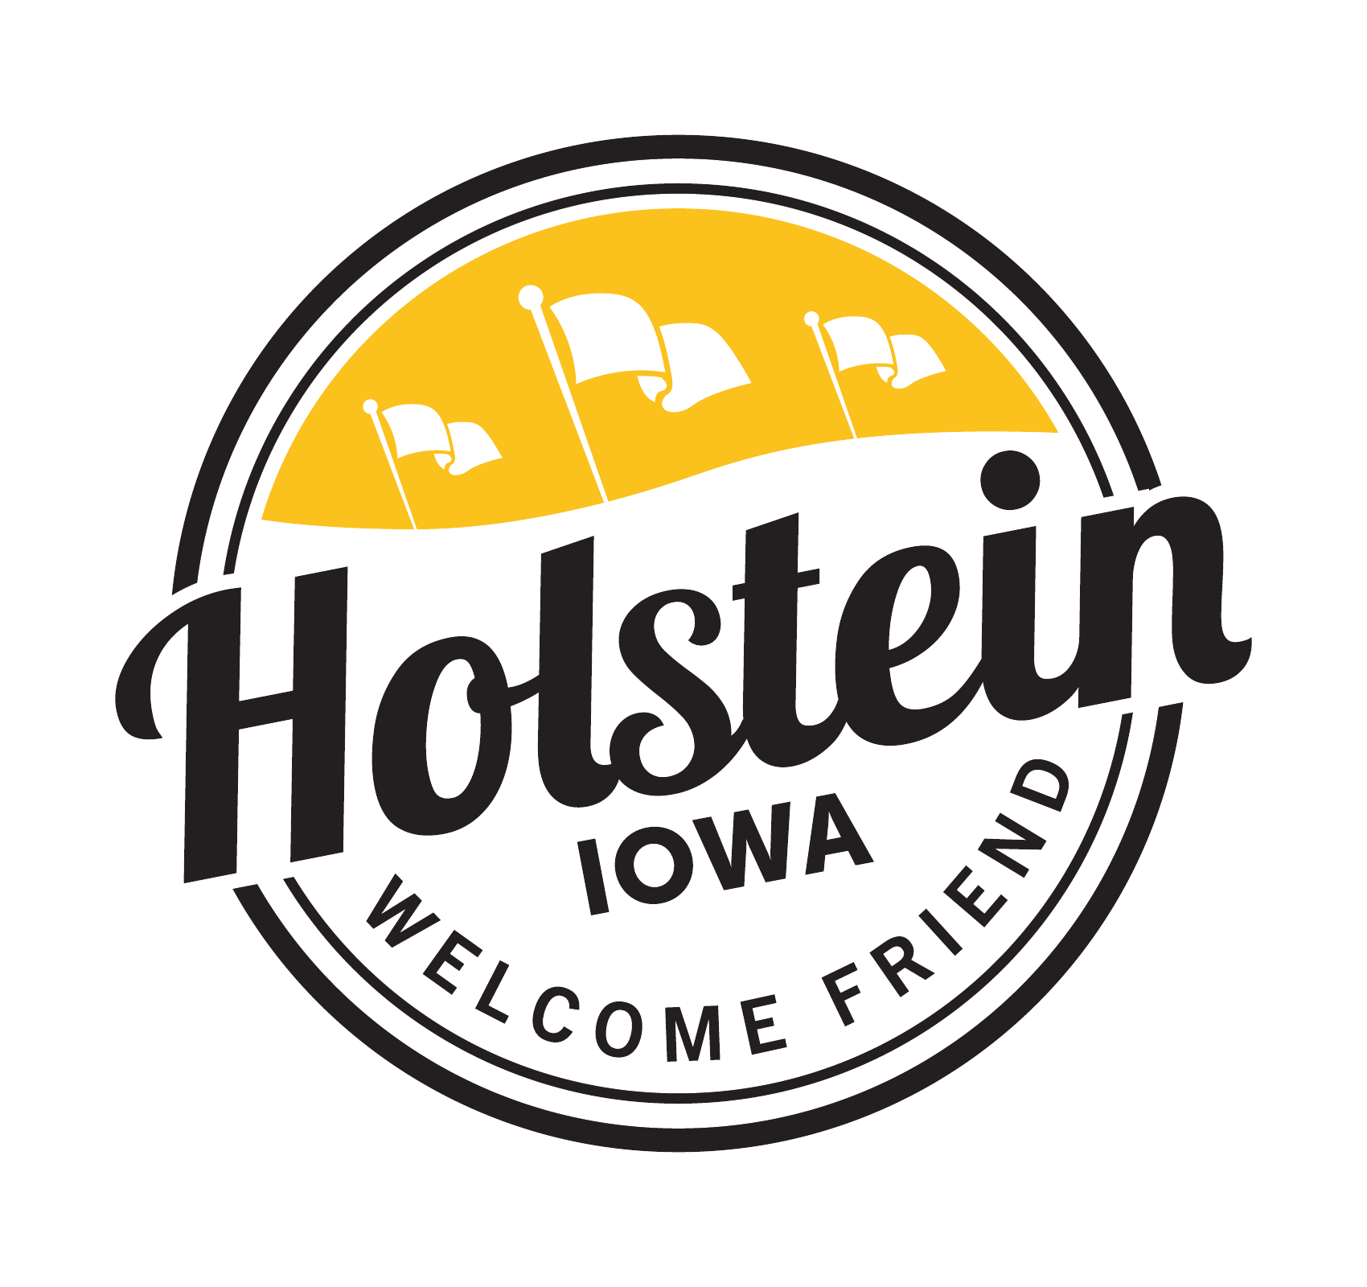
HOLSTEIN CITY COUNCIL
REGULAR MEETING
Tuesday, September 8 2026
5:00 PM – Holstein City Hall Council Chambers

AGENDA
POSTED 08/10/2026
City Hall
Library
Post Office
Signature_________________
CALL TO ORDER
PLEDGE OF ALLEGIANCE
ROLL CALL OF COUNCIL MEMBERS

CONSENT AGENDA
All items under the Consent Agenda will be enacted by one motion. Those items will not be discussed separately unless a request is made before the council votes on the motion.
- Agenda
- Minutes of August 11th, Regular Council Meeting, August 25th, Special Meeting
- Claims

CITIZEN FORUM
This time is set aside for public comments regarding issues not on the agenda. No action or discussion shall take place at this time on issues brought before the council.

BUSINESS
- Public Hearing on Proposed Amendment to the Holstein Urban Renewal Area No. 3
- Resolution 26-44 to Approve Urban Renewal Plan Amendment for the Holstein Urban Renewal Area No. 3
- Resolution26-41 Authorizing Internal Advance for Funding of Urban Renewal Project
- Resolution 26- 42 Establishing Hourly Wages for City Employees
- Resolution 26-43 Approval WWSIP Pay Request No. 6
- Benning Drive Storm Sewer Project – Alternate Design Route, Easements, and Cost Considerations
- Approval of Treasurer’s Report and Budget Report

DEPARTMENTAL REPORTS
- Wastewater Treamentment Project – Progress Report
- Sheriff Office Monthly Call Report
- Mayor Report
- Public Works Report
- Community Center Report
- Taxi Report
- Library Report
- Administrator Report

ADJOURN

