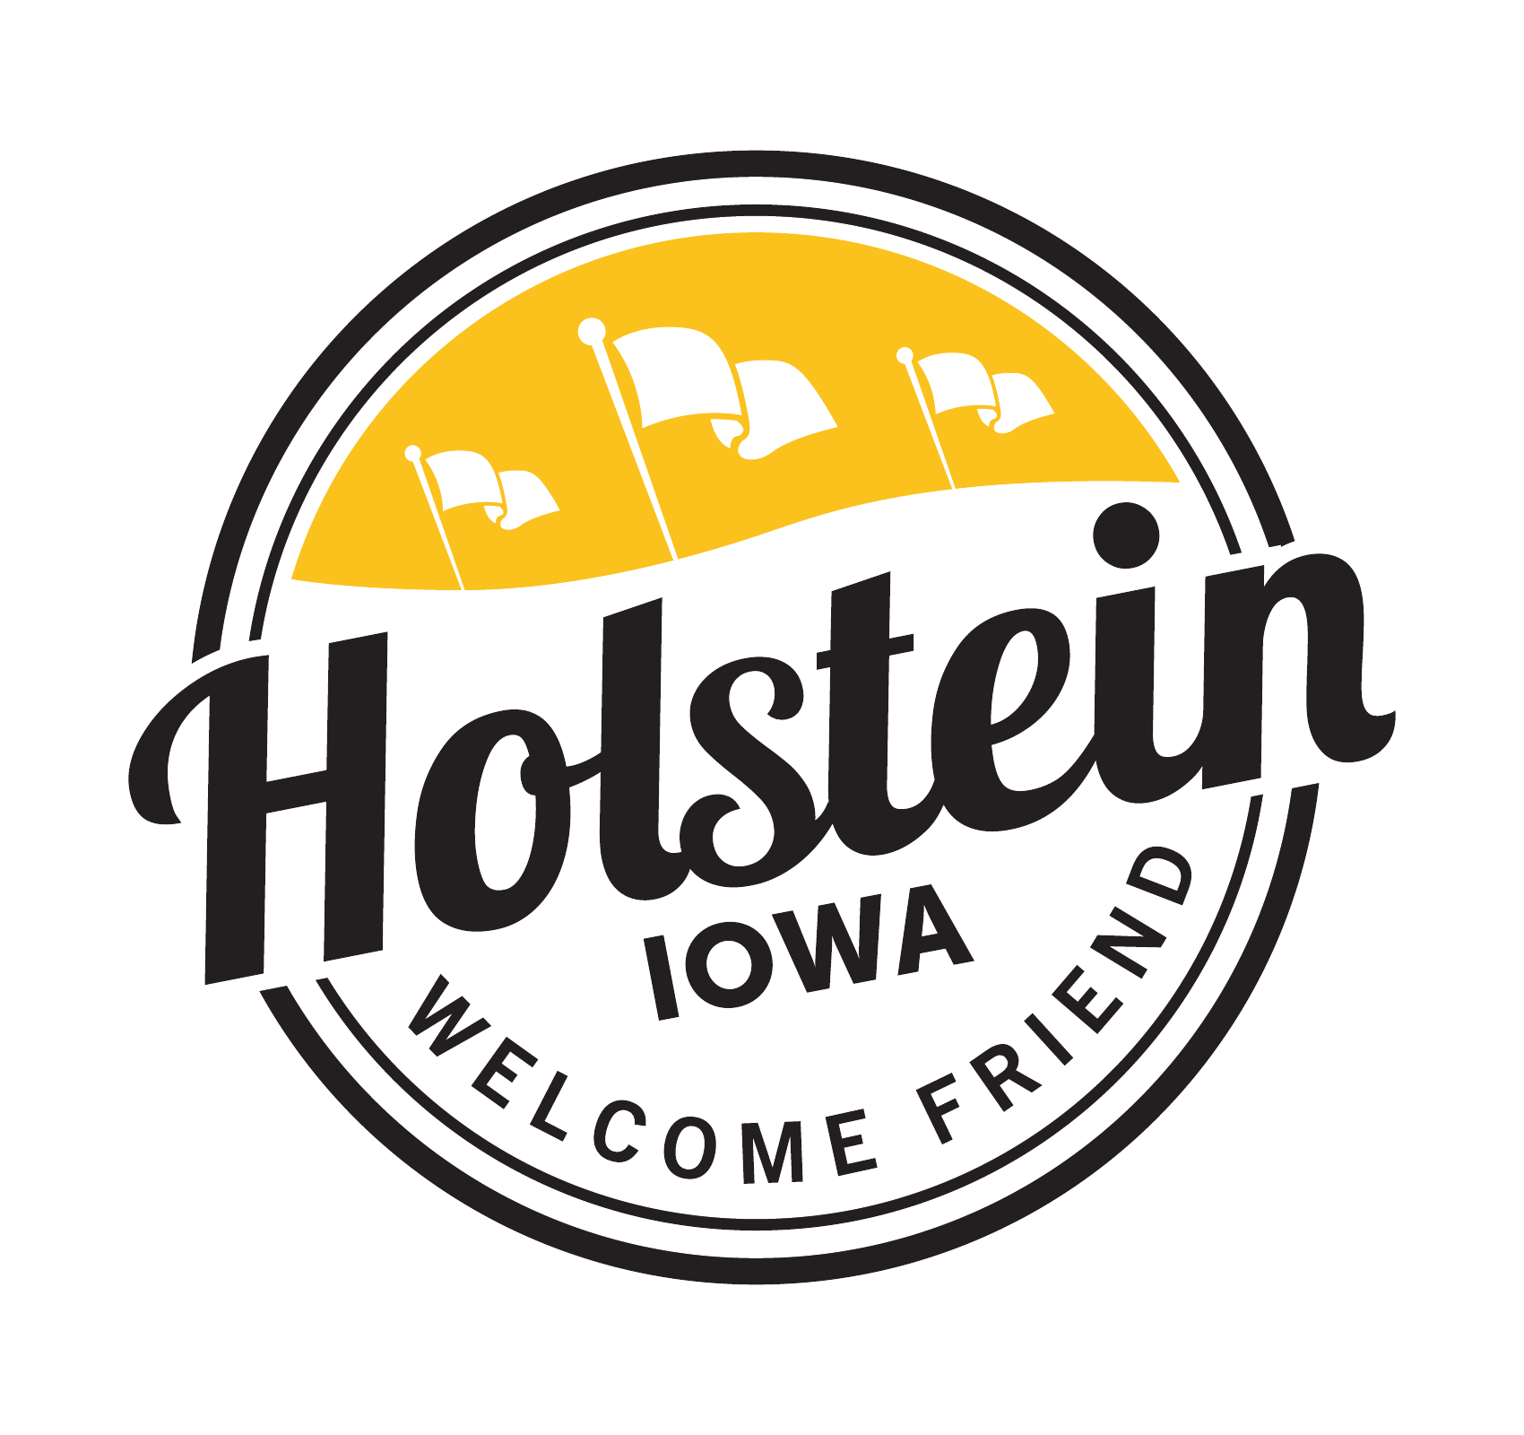
HOLSTEIN CITY COUNCIL
REGULAR MEETING
Tuesday, June 9, 2026
5:00 PM – Holstein City Hall Council Chambers

AGENDA
POSTED 06/08/2026
City Hall
Library
Post Office
Signature_________________
CALL TO ORDER
PLEDGE OF ALLEGIANCE
ROLL CALL OF COUNCIL MEMBERS

CONSENT AGENDA
All items under the Consent Agenda will be enacted by one motion. Those items will not be discussed separately unless a request is made before the council votes on the motion.
- Agenda
- Minutes of May 26th, Regular Council Meeting
- Claims
- Approval of TA Express Liquor License Class B

CLOSED SESSION
Pursuant to Iowa Code § 21.5(1)(c) to discuss strategy with legal counsel regarding pending litigation

CITIZEN FORUM
This time is set aside for public comments regarding issues not on the agenda. No action or discussion shall take place at this time on issues brought before the council.

BUSINESS
- Iowa DOT discuss the plans for the US 20 & US 59 junctions
- Sheriff’s Department – Electric Bikes and Scooters, and Side by Sides
- Review plans and Specifications for the Benning Drive Storm Sewer Project
- Set a public Hearing to approve Plans, Specifications, Form of contract and Engineer’s Estimate of Cost for Benning Drive Storm Sewer July 14th, 2026
- Set Date for Bid letting for the Benning Drive Storm Sewer July 9, 2026, 10:00 am
- Set time and place for public forum regarding the Benning Drive Storm Sewer Project
- Confirm Easements are Good to Certify. Clarify timing of easement agreements around public forum
- Engineer update on WWSI Project
- Discuss North Main Park – Repairs
- Approval of Pro Track and Tennis Proposal and Bostwick Fencing Estimate

DEPARTMENTAL REPORTS
- Mayor Report
- Public Works Report
- Community Center Report
- Treasurer’s Report, Budget Report, Administrator, Taxi, Utility Billing, Engineering Projects, Library, Pet Registration and in-House Nuisance Enforcement, and Nuisance Logs

ADJOURN

